An Examination of Eating Behaviours at University Debating Tournaments

Madeleine Rogers
BSW, University of Sydney

Abstract
Eating disorders and disordered eating behaviours have been on the rise in recent decades. Current research into eating behaviours indicates that several sociocultural factors can contribute to abnormal eating patterns. University debating is highly competitive, and many elite debaters have found that their eating patterns changed due to participating in debating tournaments. This paper interviews three elite debaters to identify what caused their eating habits to change. In doing so, this research project was able to highlight some of the key concerns in university debating, and the effects of stress on debaters’ eating behaviours.

Keywords
Disordered eating, debating, eating habits, stress

Introduction
Research projects can both reaffirm existing theories and challenge initial assumptions. My research question was, ‘‘What impacts does competitive university debating have on eating patterns amongst university debating students who reside in Sydney?’’ This research project helped me better understand the pressing issues in debating circles, but the conclusions that my research participants made were relatively bleak. This essay will first explore the methodology and data collection process used in my research project. I will then discuss the project's findings and examine the differences between these findings and pre-existing research. Next, I will consider what I could have changed to improve the quality of my project and the challenges that I encountered in collecting the data. Finally, I will explore the aspects of this project that will be useful to me as I become a practising social worker.
Methods
The research project focused on a qualitative data approach. It was conducted through interviews with the participants. While a few of the questions were closed-ended questions, the vast majority were open-ended questions. The interviews were semi-structured to ensure the data collected was relevant to the research project (D’Cruz & Jones, 2013). The qualitative data was based on participants narrating their experiences and discussing the impact of debating in their own words. This qualitative approach allowed for greater subjectivity, and the in-depth discussions helped me form new insights into the effects of debating on eating patterns (D’Cruz & Jones, 2013).
Thematic analysis was then used to analyse the qualitative data collected (Shaw & Holland, 2014). All interviews were recorded and then transcribed onto a computer. After this, the data was categorised, and different phrases in the data were coded (Shaw & Holland, 2014). After examining the codes, themes in the data were identified (Shaw & Holland, 2014). The themes were reviewed to ensure that the data supported each one. Finally, a thematic map was created (Shaw & Holland, 2014).
The participants for this research project were selected to include people who all had similar levels of debating experience and participated in a similar number of tournaments each year. The semi-structured interviews were conducted face-to-face, and the interviews were recorded and then transcribed. The data I collected helped me reaffirm my own experiences in debating. Using thematic analysis, I categorised the data into five key themes: fitting in, stress, coping behaviours, body image and sense of self (Figure 1). The thematic analysis table and thematic analysis map help illustrate the impact of debating on people’s mental and physical well-being. Participants described significant changes to their eating habits because of debating. Each participant mentioned that they would frequently skip meals and felt that the debating environment fuelled abnormal eating behaviours. All participants changed their eating habits to fit in with the rest of the debaters, and two of the participants had worse body image and sense of self (Table 1).

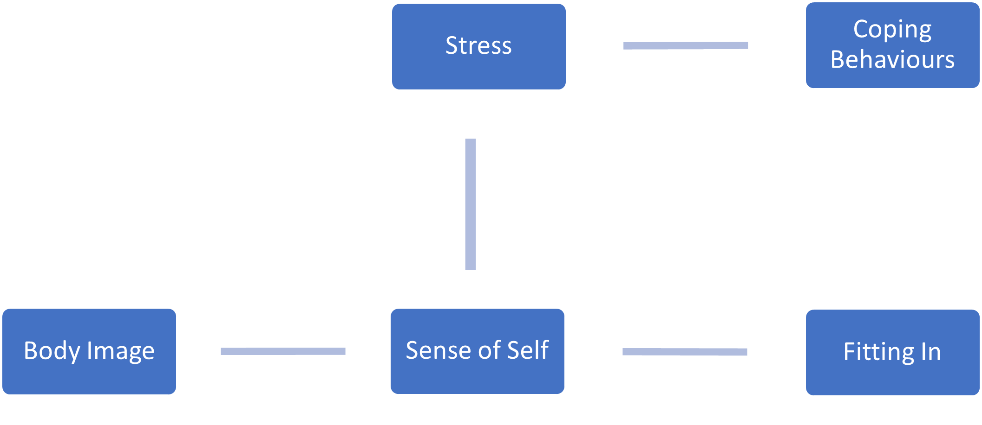
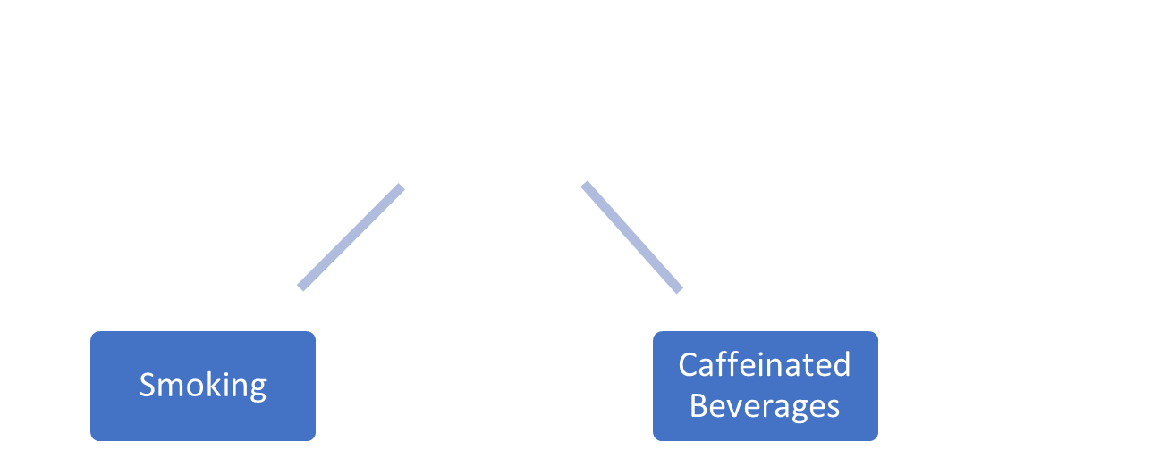

Figure 1: Thematic Analysis Map

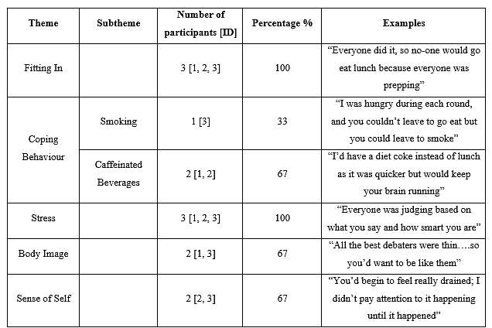
Table 1: Thematic Analysis Results Table
Discussion
When the participants’ teams were successful or there was a prestigious competition, each participant found their eating habits would worsen. Interestingly, two participants said they adopted the eating habits they had in debating during other stressful times in their lives, such as in the lead up to university examinations. There are significant limitations that minimise the usefulness of this research project, largely due to the sample size of the project. However, the participants’ commentary on how normalised this is in debating suggests that it is a persistent problem that needs to be addressed. I was expecting to find data that aligned with my experiences; however, some of my collected data was quite troubling. Two of the participants felt nothing could be done to improve debating’s atmosphere, and that unusual eating habits are intrinsic to the stressful environment within debating.
University debating is a niche activity, and there are few academic studies on university debaters’ behaviour. One study in the United States suggested that almost 30% of debaters found that their academics, health, and stress worsened due to debating (Williams, McGee & Worth, 2001). The data I have collected indicates that this pattern is continuing in Australia. However, the research participants in this study were all women. Australian debating has longstanding sexism issues that affect women’s ability to succeed in the activity (Utton, 2013; Pierson, 2013). Thus, this data may not reflect men’s experiences in debating, as women are more likely to have to deal with external stresses from sexism (Zucker & Landry, 2007). However, the data collected indicates that each research participant changed their eating behaviours due to debating-related pressures. This also aligns with literature that suggests that women are more prone to disordered eating (Zucker & Landry, 2007).
While there is limited existing research on eating behaviours in debating, this research aligns with other work on university students in high-stress situations. Debaters must contend with high-pressure debating tournaments on top of university work, employment, and social pressures (McDonald, 2001). None of the research participants discussed their eating behaviours with other debaters. These actions may provide insight into the social barriers to accessing mental health support. The data from this research project can be used to help expand research into eating behaviours, mental illnesses, stress and barriers to seeking mental health support for competitive university debaters.
As someone who has debated previously, I expected the research participants to reaffirm my beliefs. I encountered some problems due to being an ‘‘insider researcher’’, as I tended to assume what people would say (Corbin Dwyer & Buckle, 2009). It was only through listening to my recordings that I realised that people had some minor but quite radically different perspectives to my own. I think that being an ‘‘insider researcher’’ was helpful, as I understood a lot of the debating terminology used and was aware of what follow-up questions should be asked (Corbin Dwyer & Buckle, 2009). However, I acknowledge that ‘‘outsider researchers’’ should also research into debating, as they can approach research from a different perspective and potentially validate my findings (Corbin Dwyer & Buckle, 2009).
I have applied to do social work honours due to this research project. While I am aware that it will be radically different to this experience, I have discovered that I really enjoy research and data collection. I had a very positive experience; however, it was not without challenges. One of the biggest problems I had was identifying what questions would be best to ask. While I was completing the project, I made some adjustments to my research questions based on what the participants were discussing. I had assumed that the participants would have tried to fix their eating habits, as I had tried to fix them when I was a debater. However, none of the interviewed participants attempted to correct their eating habits. Instead, they discussed how the culture and environment prevented them from even attempting to change their eating behaviours. This was not an outcome I was expecting from my research, but it does add credence to my concerns about eating habits at debating competitions.
I encountered one ethical dilemma concerning the confidentiality of participants. Debating is such an insular sport that keeping the participants’ concerns anonymous is challenging. I discussed this with the participants prior to their involvement in the study, and all of them said they would be comfortable being known as participants if such a situation occurred. One of the changes I would make if I were to repeat this experiment would be to reframe my questions. At times, I felt my questions were leading questions. This was unintentional, but I am concerned that I primed the participants to respond in a certain way to the questions I asked (Hugman, 2009). I need to work on my interviewing skills and on creating neutral, unbiased questions (Hugman, 2009). In the future, I would be interested in expanding this study and interviewing more people, as I think this is a genuine problem in the debating community. Due to my small sample size, I cannot apply this data to broader debating circles in Australia and overseas.
This research project positively contributes to broader knowledge as it sheds light on an important issue in the debating community. As a social worker, it is essential to remember that each community will have complex and unique issues. Moreover, social workers continuously engage in research. Some social workers focus on community development and thus must attend focus groups and interview community members. Other social workers must advocate for their clients’ needs by engaging in the research process (Hugman, 2009). Understanding research is also crucial for social workers, as we must continuously read literature to understand the current concerns in the community. The ethical considerations involved in the research process are also important ethical guidelines for social work practice (D’Cruz & Jones, 2013). We must constantly reflect on our behaviour and make sure it is aligned with benevolence and centred on improving the most vulnerable lives in our community (Hugman, 2009). Social research and social work focus on making society more just, and both social workers and researchers must work together to develop a more inclusive society.
In conducting this research project, I realised how diligent social researchers must be. It is crucial to design research projects that work with researchers’ timelines and contribute to broader social knowledge (D’Cruz & Jones, 2013). Until this project, I hadn’t considered how essential it is for research to benefit individuals and facilitate change. I have always preferred qualitative research, but this project has made me understand the value in quantitative and mixed-method approaches. While my qualitative data allowed for in-depth discussions with research participants, quantitative data can provide analysis of the prevalence of the issue.
Conclusion
Research is an integral part of social work and social justice action. Social workers are better advocates for clients if they can understand social research’s processes and outcomes. I am looking forward to continuing to build on my research skills not only in the university but in the workplace.

Reference List
Corbin Dwyer, S., & Buckle, J. (2009). The Space Between: On Being an Insider-Outsider in Qualitative Research. International Journal of Qualitative Methods, 8(1), 54-63. https://doi.org/10.1177/1609406918788176
D′Cruz, H. & Jones, M. (2013). Social Work Research in Practice: Ethical and Political Contexts (2nd ed.). SAGE Publications.
Hugman, R. (2009). Social work research and ethics. In I. Shaw, K. Briar-Lawson, J. Orme & R. Ruckdeschel (Eds.), The SAGE handbook of social work research (pp. 149-163). SAGE Publications. https://doi.org/10.4135/9780857021106
McDonald, K. (2001). Demanding Expectations: Surviving and Thriving as a Collegiate Debate Coach. Argumentation and Advocacy: Special Issue on Forensics, 38(2), 115–120. https://doi.org/10.1080/00028533.2001.11821562
Pierson, E. (2013). Men outspeak women. Monash Association of Debaters. https://monashdebaters.com/men-outspeak-women
Shaw, I. & Holland, S. (2014). Qualitative Designs in: Doing qualitative research in social work. (pp. 80-100). SAGE Publications. https://doi.org/10.4135/9781473906006
Utton, C. (2013, March 5). Who said misogyny’s dead? Female students receive sexist heckles at Glasgow Ancients debating competition. The Independent. https://www.independent.co.uk/student/news/who-said-misogyny-s-dead-female-students-receive-sexist-heckles-at-glasgow-ancients-debating-competition-8521460.html
Williams, D., McGee, B., & Worth, D. (2001). University Student Perceptions of the Efficacy of Debate Participation: An Empirical Investigation. Argumentation and Advocacy, 37(4), 198–209. https://doi.org/10.1080/00028533.2001.11951670
Zucker, A., & Landry, L. (2007). Embodied Discrimination: The Relation of Sexism and Distress to Women’s Drinking and Smoking Behaviours. Sex Roles. 56, 193-203. https://doi.org/10.1007/s11199-006-9163-3

